**Exercise 7: Packages**

**Scenario 1:** Group all customer-related procedures and functions into a package.

**Question:** Create a package **CustomerManagement** with procedures for adding a new customer, updating customer details, and a function to get customer balance.

SET SERVEROUTPUT ON;

CREATE OR REPLACE PACKAGE CustomerManagement AS

PROCEDURE AddCustomer (

p_CustomerID IN NUMBER,

p_Name IN VARCHAR2,

p_DOB IN DATE,

p_Balance IN NUMBER

);

PROCEDURE UpdateCustomer (

p_CustomerID IN NUMBER,

p_Name IN VARCHAR2,

p_DOB IN DATE,

p_Balance IN NUMBER

);

FUNCTION GetCustomerBalance (

p_CustomerID IN NUMBER

) RETURN NUMBER;

END CustomerManagement;

/

CREATE OR REPLACE PACKAGE BODY CustomerManagement AS

PROCEDURE AddCustomer (

p_CustomerID IN NUMBER,

p_Name IN VARCHAR2,

p_DOB IN DATE,

p_Balance IN NUMBER

) IS

BEGIN

INSERT INTO Customers (CustomerID, Name, DOB, Balance, LastModified)

VALUES (p_CustomerID, p_Name, p_DOB, p_Balance, SYSDATE);

EXCEPTION

WHEN DUP_VAL_ON_INDEX THEN

DBMS_OUTPUT.PUT_LINE('Error: CustomerID already exists.');

WHEN OTHERS THEN

DBMS_OUTPUT.PUT_LINE('Error: ' || SQLERRM);

END AddCustomer;

PROCEDURE UpdateCustomer (

p_CustomerID IN NUMBER,

p_Name IN VARCHAR2,

p_DOB IN DATE,

p_Balance IN NUMBER

) IS

BEGIN

UPDATE Customers

SET Name = p_Name,

DOB = p_DOB,

Balance = p_Balance,

LastModified = SYSDATE

WHERE CustomerID = p_CustomerID;

IF SQL%ROWCOUNT = 0 THEN

DBMS_OUTPUT.PUT_LINE('Error: CustomerID not found.');

END IF;

EXCEPTION

WHEN OTHERS THEN

DBMS_OUTPUT.PUT_LINE('Error: ' || SQLERRM);

END UpdateCustomer;

FUNCTION GetCustomerBalance (

p_CustomerID IN NUMBER

) RETURN NUMBER IS

v_Balance NUMBER;

BEGIN

SELECT Balance INTO v_Balance

FROM Customers

WHERE CustomerID = p_CustomerID;

RETURN v_Balance;

EXCEPTION

WHEN NO_DATA_FOUND THEN

RETURN NULL; -- or you might want to handle it differently

WHEN OTHERS THEN

DBMS_OUTPUT.PUT_LINE('Error: ' || SQLERRM);

RETURN NULL;

END GetCustomerBalance;

END CustomerManagement;

/

BEGIN

CustomerManagement.AddCustomer(

p_CustomerID => 3,

p_Name => 'Parambrata Chatterjee',

p_DOB => DATE '2002-12-15',

p_Balance => 1700

);

END;

/

DECLARE

v_Balance NUMBER;

BEGIN

v_Balance := CustomerManagement.GetCustomerBalance(p_CustomerID => 3);

DBMS_OUTPUT.PUT_LINE('Customer Balance: ' || v_Balance);

END;

/

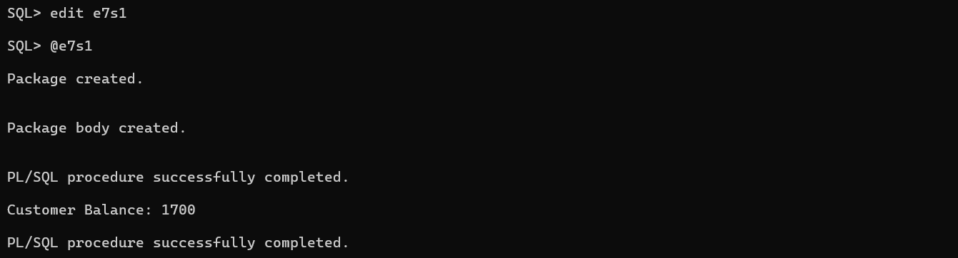

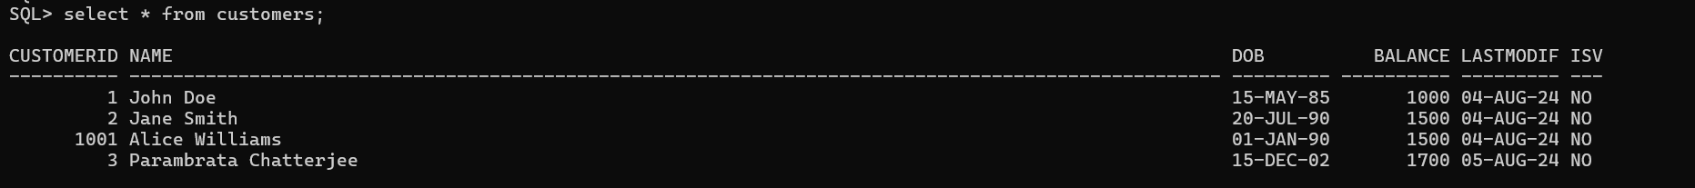

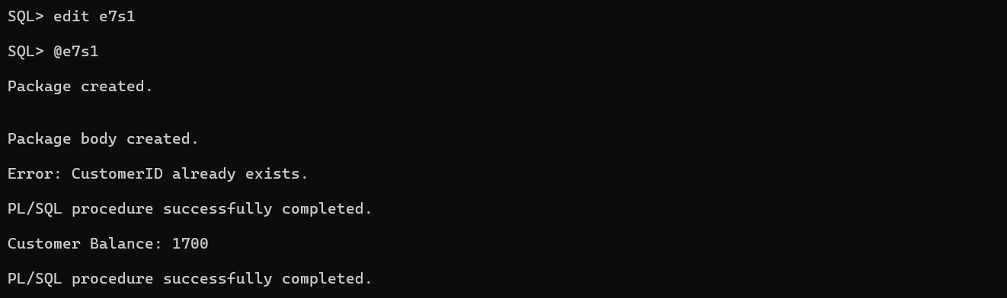

**Scenario 2:** Create a package to manage employee data.

**Question:** Write a package **EmployeeManagement** with procedures to hire new employees, update employee details, and a function to calculate annual salary.

SET SERVEROUTPUT ON;

CREATE OR REPLACE PACKAGE EmployeeManagement AS

PROCEDURE HireEmployee (

p_EmployeeID IN NUMBER,

p_Name IN VARCHAR2,

p_Position IN VARCHAR2,

p_Salary IN NUMBER,

p_Department IN VARCHAR2,

p_HireDate IN DATE

);

PROCEDURE UpdateEmployee (

p_EmployeeID IN NUMBER,

p_Name IN VARCHAR2,

p_Position IN VARCHAR2,

p_Salary IN NUMBER,

p_Department IN VARCHAR2,

p_HireDate IN DATE

);

FUNCTION CalculateAnnualSalary (

p_EmployeeID IN NUMBER

) RETURN NUMBER;

END EmployeeManagement;

/

CREATE OR REPLACE PACKAGE BODY EmployeeManagement AS

PROCEDURE HireEmployee (

p_EmployeeID IN NUMBER,

p_Name IN VARCHAR2,

p_Position IN VARCHAR2,

p_Salary IN NUMBER,

p_Department IN VARCHAR2,

p_HireDate IN DATE

) IS

BEGIN

INSERT INTO Employees (EmployeeID, Name, Position, Salary, Department, HireDate)

VALUES (p_EmployeeID, p_Name, p_Position, p_Salary, p_Department, p_HireDate);

EXCEPTION

WHEN DUP_VAL_ON_INDEX THEN

DBMS_OUTPUT.PUT_LINE('Error: EmployeeID already exists.');

WHEN OTHERS THEN

DBMS_OUTPUT.PUT_LINE('Error: ' || SQLERRM);

END HireEmployee;

PROCEDURE UpdateEmployee (

p_EmployeeID IN NUMBER,

p_Name IN VARCHAR2,

p_Position IN VARCHAR2,

p_Salary IN NUMBER,

p_Department IN VARCHAR2,

p_HireDate IN DATE

) IS

BEGIN

UPDATE Employees

SET Name = p_Name,

Position = p_Position,

Salary = p_Salary,

Department = p_Department,

HireDate = p_HireDate

WHERE EmployeeID = p_EmployeeID;

IF SQL%ROWCOUNT = 0 THEN

DBMS_OUTPUT.PUT_LINE('Error: EmployeeID not found.');

END IF;

EXCEPTION

WHEN OTHERS THEN

DBMS_OUTPUT.PUT_LINE('Error: ' || SQLERRM);

END UpdateEmployee;

FUNCTION CalculateAnnualSalary (

p_EmployeeID IN NUMBER

) RETURN NUMBER IS

v_Salary NUMBER;

BEGIN

SELECT Salary INTO v_Salary

FROM Employees

WHERE EmployeeID = p_EmployeeID;

RETURN v_Salary * 12;

EXCEPTION

WHEN NO_DATA_FOUND THEN

RETURN NULL;

WHEN OTHERS THEN

DBMS_OUTPUT.PUT_LINE('Error: ' || SQLERRM);

RETURN NULL;

END CalculateAnnualSalary;

END EmployeeManagement;

/

BEGIN

EmployeeManagement.HireEmployee(

p_EmployeeID => 3,

p_Name => 'Parambrata Chatterjee',

p_Position => 'Junior Developer',

p_Salary => 40000,

p_Department => 'IT',

p_HireDate => SYSDATE

);

END;

/

BEGIN

EmployeeManagement.UpdateEmployee(

p_EmployeeID => 3,

p_Name => 'Parambrata Chatterjee',

p_Position => 'Senior Developer',

p_Salary => 70000,

p_Department => 'IT',

p_HireDate => SYSDATE

);

END;

/

DECLARE

v_AnnualSalary NUMBER;

BEGIN

v_AnnualSalary := EmployeeManagement.CalculateAnnualSalary(p_EmployeeID => 3);

DBMS_OUTPUT.PUT_LINE('Annual Salary: ' || v_AnnualSalary);

END;

/

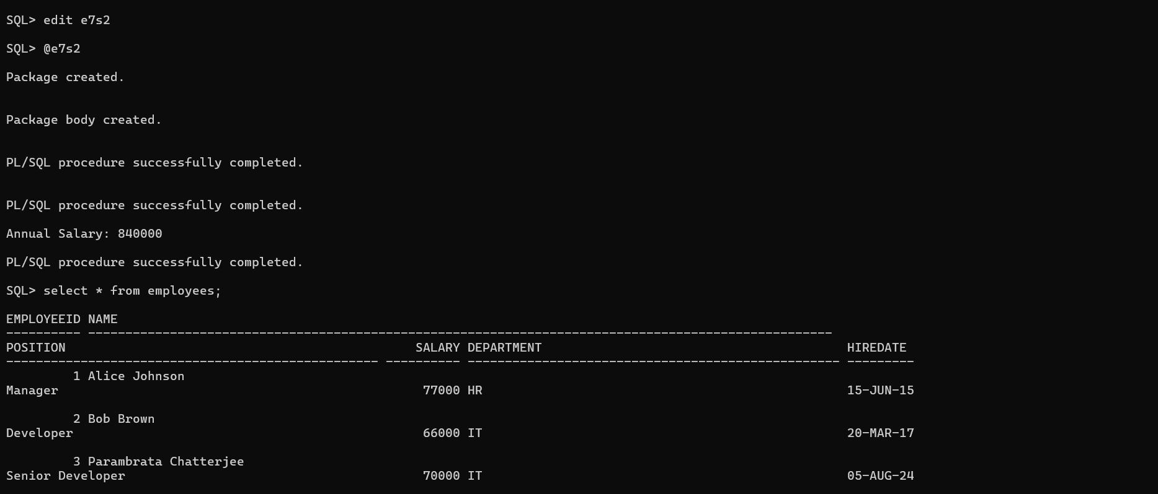

**Scenario 3:** Group all account-related operations into a package.

**Question:** Create a package **AccountOperations** with procedures for opening a new account, closing an account, and a function to get the total balance of a customer across all accounts.

CREATE OR REPLACE PACKAGE AccountOperations AS

PROCEDURE OpenAccount (

p_AccountID IN NUMBER,

p_CustomerID IN NUMBER,

p_AccountType IN VARCHAR2,

p_Balance IN NUMBER

);

PROCEDURE CloseAccount (

p_AccountID IN NUMBER

);

FUNCTION GetTotalBalance (

p_CustomerID IN NUMBER

) RETURN NUMBER;

END AccountOperations;

/

CREATE OR REPLACE PACKAGE BODY AccountOperations AS

PROCEDURE OpenAccount (

p_AccountID IN NUMBER,

p_CustomerID IN NUMBER,

p_AccountType IN VARCHAR2,

p_Balance IN NUMBER

) IS

BEGIN

INSERT INTO Accounts (AccountID, CustomerID, AccountType, Balance, LastModified)

VALUES (p_AccountID, p_CustomerID, p_AccountType, p_Balance, SYSDATE);

EXCEPTION

WHEN DUP_VAL_ON_INDEX THEN

DBMS_OUTPUT.PUT_LINE('Error: AccountID already exists.');

WHEN OTHERS THEN

DBMS_OUTPUT.PUT_LINE('Error: ' || SQLERRM);

END OpenAccount;

PROCEDURE CloseAccount (

p_AccountID IN NUMBER

) IS

BEGIN

DELETE FROM Transactions

WHERE AccountID = p_AccountID;

DELETE FROM Accounts

WHERE AccountID = p_AccountID;

IF SQL%ROWCOUNT = 0 THEN

DBMS_OUTPUT.PUT_LINE('Error: AccountID not found.');

END IF;

EXCEPTION

WHEN OTHERS THEN

DBMS_OUTPUT.PUT_LINE('Error: ' || SQLERRM);

END CloseAccount;

FUNCTION GetTotalBalance (

p_CustomerID IN NUMBER

) RETURN NUMBER IS

v_TotalBalance NUMBER;

BEGIN

SELECT SUM(Balance) INTO v_TotalBalance

FROM Accounts

WHERE CustomerID = p_CustomerID;

RETURN NVL(v_TotalBalance, 0);

EXCEPTION

WHEN OTHERS THEN

DBMS_OUTPUT.PUT_LINE('Error: ' || SQLERRM);

RETURN 0;

END GetTotalBalance;

END AccountOperations;

/

BEGIN

AccountOperations.OpenAccount(

p_AccountID => 6,

p_CustomerID => 2,

p_AccountType => 'Savings',

p_Balance => 45000

);

END;

/

BEGIN

AccountOperations.CloseAccount(p_AccountID => 2);

END;

/

DECLARE

v_TotalBalance NUMBER;

BEGIN

v_TotalBalance := AccountOperations.GetTotalBalance(p_CustomerID => 2);

DBMS_OUTPUT.PUT_LINE('Total Balance: ' || v_TotalBalance);

END;

/

